

**FINAL SEMESTER PROJECT**

**BBMS(Blood Bank Management System)**

**Submitted To: Sir Mukhtiar Zamin**

**Group Members:**

**Hamza Bin Ahmed(Leader) Reg# FA18-BCS-084**

**Hanzala Shahid Reg#**

**Sharjeel khan Reg#**

**Abdullah-Noor-Niazi Reg#**

**Hamza-Aslam Reg#**

**Usama-Farid Reg#**

**Usman Jadoon Reg# FA18-BCS-100**

## 1.1 Database Planning

We can Divided our Blood Bank into Following Sections.

### Mission Statement

The Mission statement of our project is to Create a system that will help people to find blood they wanted and to manage and handle the blood bank.

### Mission Objective

*“***Blood Bank Management System** (BBMS) is a web-based **system** that will handle all the task which are performed in the **blood bank**. Through our product people can easily find the blood they wanted. Our system will be user friendly so illiterate people can also use it easily. Our system will manage user record.

As our project is web-based for we will create website using:  
**Front-End**:

HTML

CSS

JAVASCRIPT

BOOTSTRAP

**Back-end:**

PHP

For Database we will use XAMPP Server PHP my admin

**Date of Starting Project:1st Dec 2020**

**Expected Date of completion: 29th Dec 2020**

### Mission Objective of Database

Mission Objective of the database is

* To maintain (Enter, Update and Delete) data on Donors
* To maintain (Enter, Update and Delete) data on receiver
* To maintain (Enter, Update and Delete) data on Blood Bank
* To maintain (Enter, Update and Delete) data on Blood Bank Admin
* To maintain (Enter, Update and Delete) data on Blood Groups
* To maintain (Enter, Update and Delete) data on Blood Request
* To maintain (Enter, Update and Delete) data on Health of Donors

### ER Diagram:

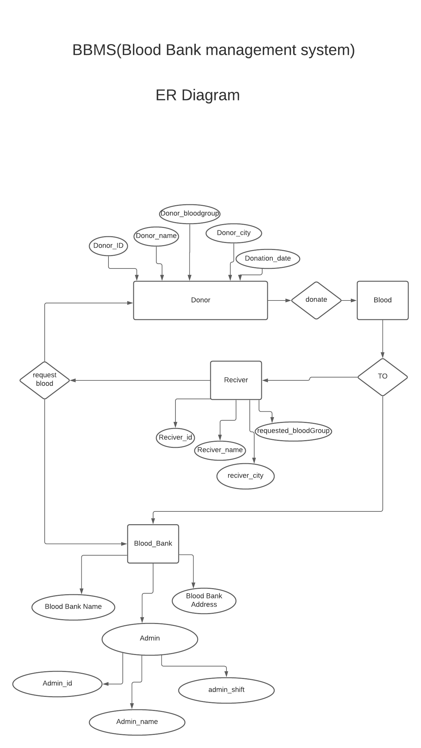

### Task Assign to Members

### Hamza-Bin-Ahmad

Hamza-Bin-Ahmad will design and develop the Login and Registration Functionalities in Our Blood Donation Management by interacting with database to validate the user.

### Abdullah Noor Niazi

Abdullah-Noor-Niazi and Hamza-Aslam will Develop and Design the Dashboard of Donors Functionalities After User will login the system.

### Hamza-Aslam

Hamza-Aslam will Develop and Design the Dashboard of Blood Bank Functionalities After User will login the system.

### Usman Jadoon And Usama Farid

Usman Jadoon have to design And Develop the Blood Section That will include Available Blood, New Donor Insertion part, Available and Not available Blood and The Prices of Blood.

### Hanzala-Shahid

Hanzala-Shahid will design Design and Develop The financial aspect of Database like Weekly, monthly, annual report. They will also create the amount spend on Blood Bank System. Beside that it will calculate the profit of the Blood Bank System. Also, they will Handle the connection of Database and Integrate the work into functional Software.

### Sharjeel khan

Sharjeel khan will look after the whole photoshop work and will work on the testing phase of our project.

### Note:

Everyone Have to provide His Part of Design to the team Leader.